|  |  |
| --- | --- |
| **AP Computer Science** | **Text Lab 01**  **1-Day Minor Assignment** |
| **First Java Program** | **80 & 100 Point Versions** |
| **Assignment Purpose:**  The purpose of this lab assignment is to demonstrate knowledge of compiling a provided Java source code file into a byte code file, and then interpreting and executing the created bytecode file. | |

This is your first lab assignment. You are not yet expected to figure out any complicated program logic. As a matter of fact you will be provided with the source code of the **80-point** version below. Your mission is to demonstrate that you can use a text editor to enter the **source** code, compile the **source** code into **bytecode**, and finally translate and **execute** the **bytecode**.

Remember one rule of Java is that the name of the *file* must match the name of the *class*. Because of this, the program will not compile because you loaded the *file* **TextLab01st.java**, but the *class* is **TextLab01v80**. You need to save the file as **TextLab01v80.java** before you begin.

When you are finished, your instructor will grade your assignment. Start by displaying the execution on the monitor, which shows that the program compiles and processes the required output correctly. After your instructor has seen the execution, show the source code file.

**Copy the program exactly as shown below:**

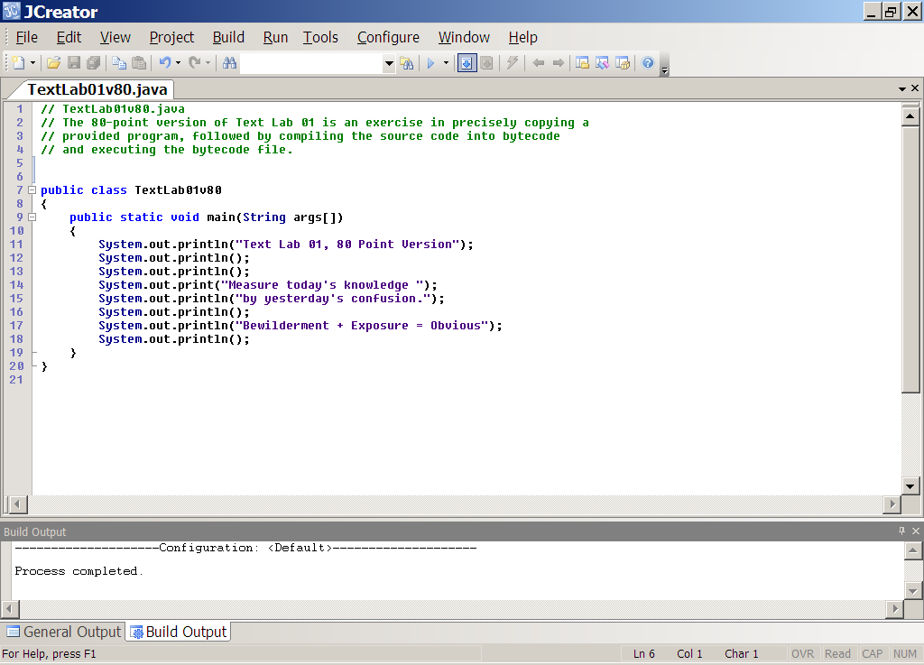

**80 Point Version Output**

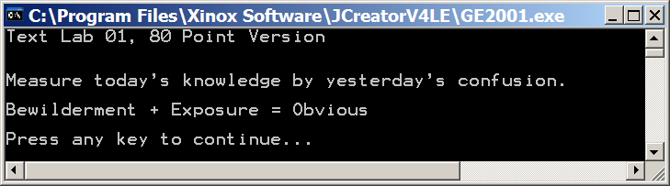

**100 Point Version Specifics**

Make sure that you first save your 80-point version, in the event that you are not able to complete the 100-point version in time. Rename the lab, **TextLab01v100.java** and then continue with the instructions below. For the **100-point** version you need to add additional program statements that are not provided. Show your understanding of creating Java text output by exactly creating the output that is shown below.

**100 Point Version Output**

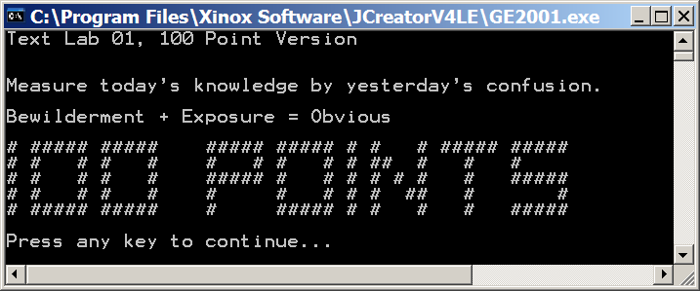

NOTE: *Do NOT use the <Tab> key for this assignment. It will completely mess up your output.*

*The tab locations in the text editor are different from the tab locations in the output window.*